Overview

The overall objective of this job aid is to help customer billing handle cancel rebill for the following scenarios:
- Interval Meter Reads manually edited in MDM after billing
- Interval Reads uploaded from field tools after billing
- Correction of corrupt interval reads in MD after billing

A BPEM case will be created if there are any changes to the interval read during a period that has already been billed. This is a case with case category EB67 Interval value has changed.

Only if the peak demand has changed will a Cancel Rebill be needed.

Business Process Procedure Overview
Steps to determine of the peak demand has changed:
- Check peak demand billed from the billing document
- Check current peak demand from the BPEM message
- If the peak demand from step 1 and 2 are not equal, perform Cancel Rebill

Cancel Rebill
- Cancel the invoice, billing and meter reading document
- Recreate the meter reading order
- Create the billing determinant request to MDM
- Once the response is received, bill and invoice the customer
Note: It is also possible to just perform steps 1 and 2, then let the nightly batch jobs take care of the rest of the steps.

Procedural Steps

Steps to determine if the billing determinant has changed:

Get the billing determinant from the billing document

Go to the Hdr Data tab of the billing document, and click on the MDUS Request checkbox.

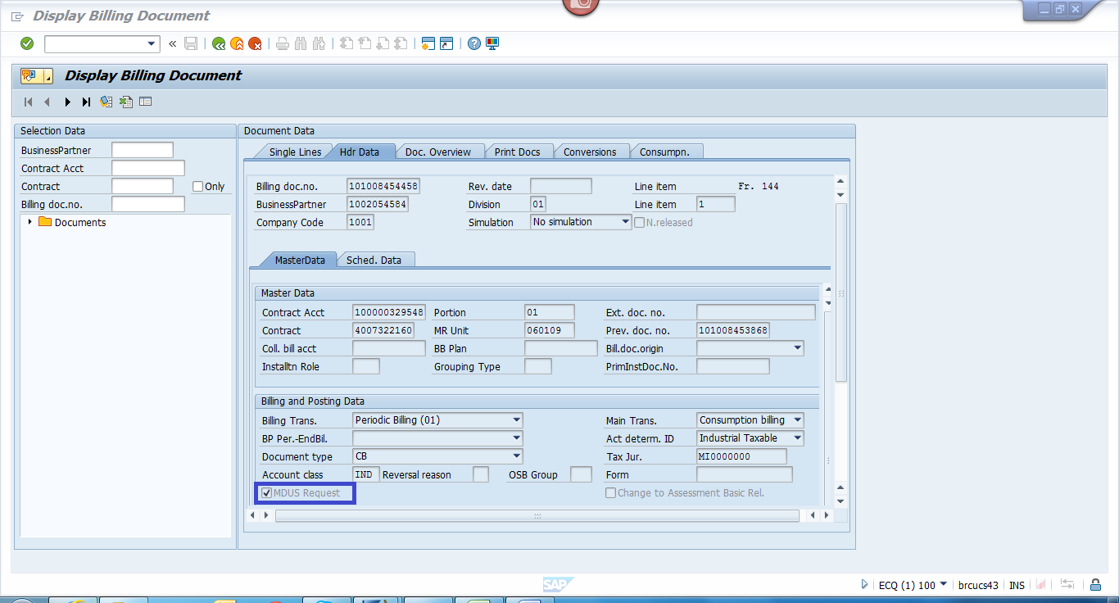

The MDUS Request will be displayed and the billing determinant can be seen in the Output Parameters on the bottom of the screen.

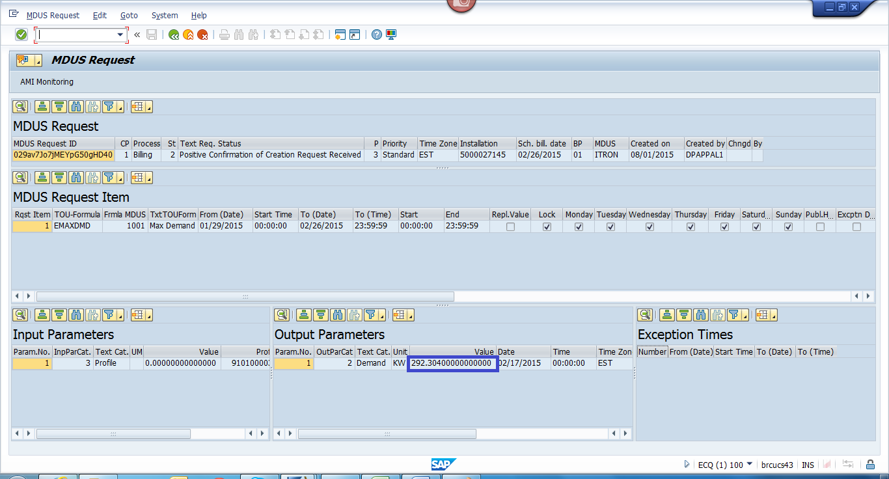

Get the new peak demand from the BPEM case

The new peak demand value is found in the Technical Data tab under Messages. For the example below, the new peak demand is 5686.

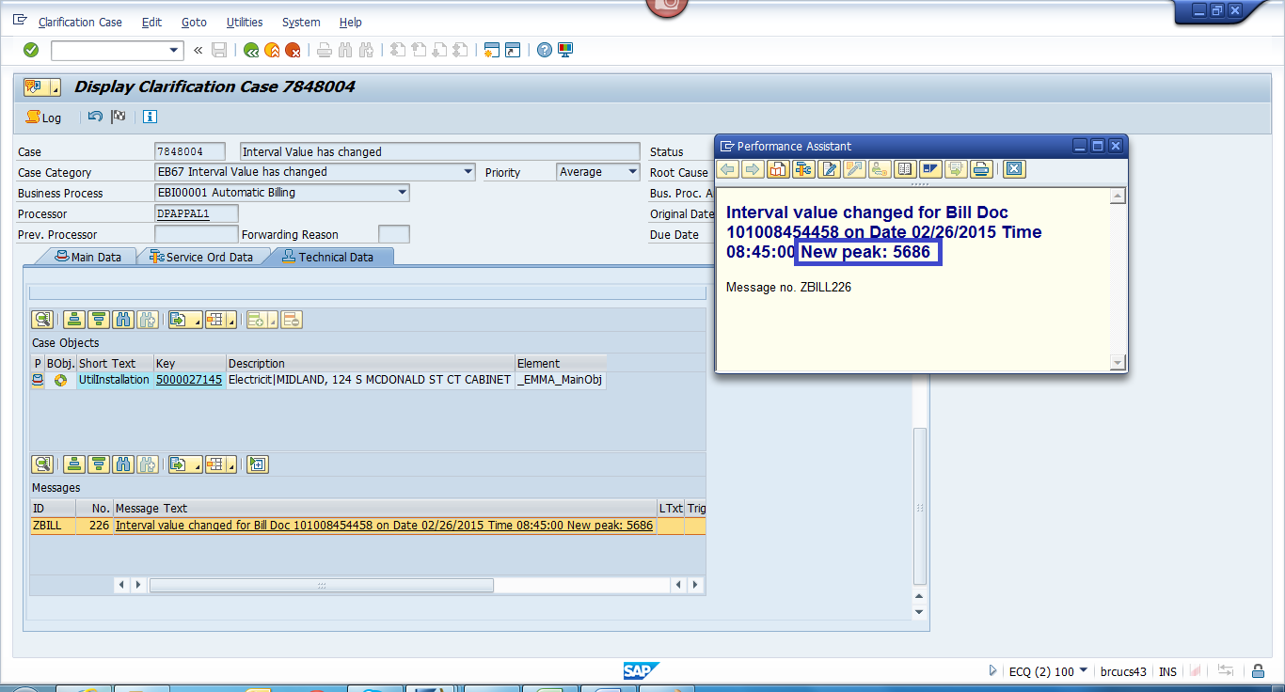

Note that the peak demand in the application log message and the peak demand billed is rounded off to the nearest whole number.

Billing team compares the billed peak demand and the new peak demand and decides if cancel rebill is needed.

Steps to perform Cancel Rebill

Use regular procedure for cancelling the invoice, bill and meter reading document.

Recreate the meter reading order
We need to recreate the meter reading order to get the latest readings. Use transaction EL01 with the Installation, Meter Reading Reason = ‘01’ and select the appropriate Scheduled Meter Reading Date.

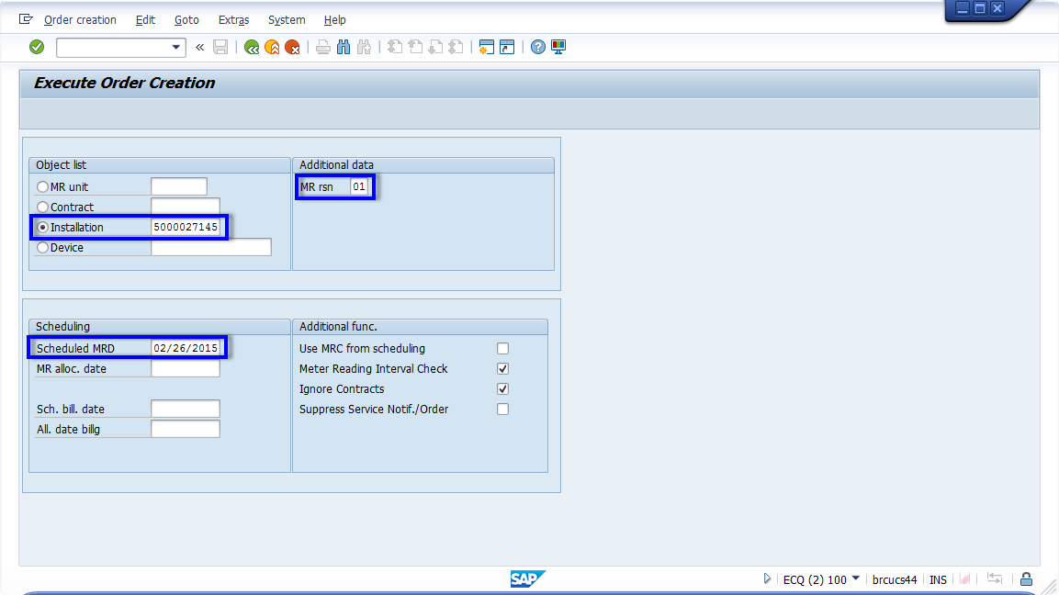

Note: Customer Billing can wait for the nightly batch jobs for the remaining steps. In this case, no additional action is needed. If Customer Billing would like to bill and invoice manually, proceed with the next steps.

Create the MDUS request
Use transaction EMDUSCRTRQ using the Installation number to create the MDUS request, also known as profile calculation request.

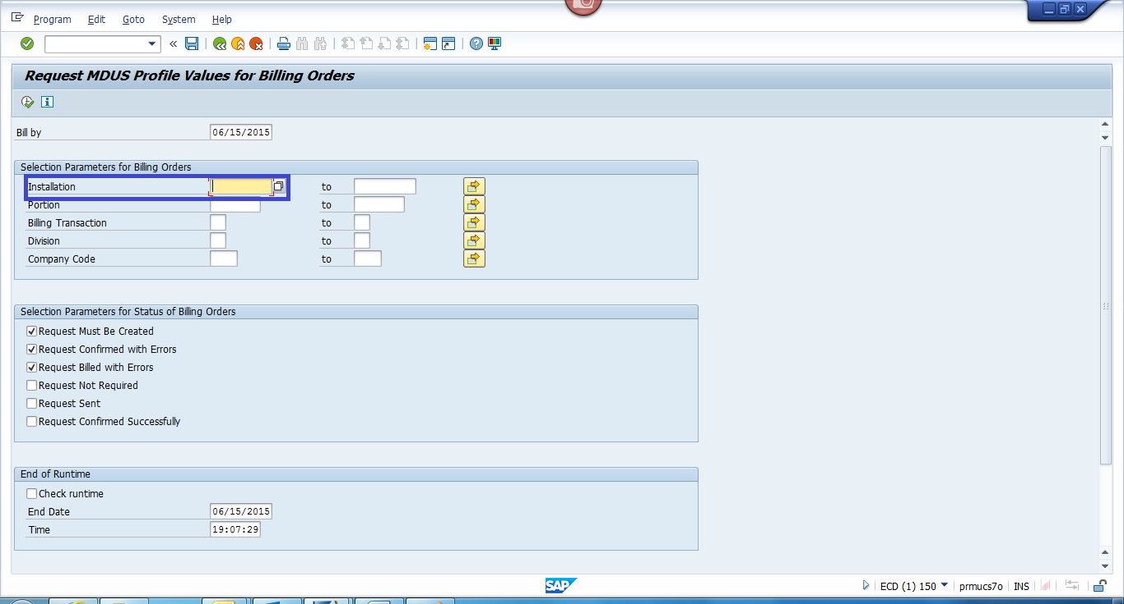
When the request gets created, the billing order MDUS status will be set to ‘02’ (Request Sent). Customer billing need to wait for the response. Once the response is received, the billing order will be set to ‘03’ (Request Confirmed Successfully). Check the MDUS Request from the billing order by clicking on the MDUS Request checkbox on the bottom of the screen. Verify that the billing determinant matches expected billing determinant from the BPEM case.

Use regular billing and invoicing procedure

